

Assignment No: 6

Date: 15th September 2026

Title: Information Theory

Name: Joe Blogs ???

Course: Bachelor of Engineering in Electronic Engineering

Subject: Digital Communications and Transmission

Lecturer: Ben Graham

Summary: Sampling and reconstruction of a sine wave

AIM:
In this assignment, we will explore the fundamental findings of information theory including Entropy, Coding Efficiency, Block Coding, Shannon’s Lossless Source Coding Theorem, Shannon - Fano and Huffman Coding.

TOTAL MARKS:
100 Marks. (Remember complete all explanations and include all calculations)

OBJECTIVES:
Complete all text explanations, step by step mathematical calculations and insert required images directly within the designated sections below.

Total Marks : 100

All work must be completed and submitted inside THIS Document

Part 1 – Entropy (25 Marks)

Question 1: What unit is Entropy measured in? (3 Marks)

Answer 1:

Question 2: What is the relationship between Entropy and Shannon Information Content? (5 Marks)

Answer 2:

Question 3: Calculate the Shannon Information Content for each character and the overall Entropy H(x) of the following characters shown in Table 1.
(12 Marks)

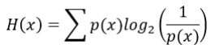

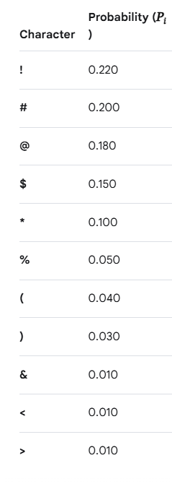

Table 1

Answer 3:

Place your image here

Question 4: Create a table and include the Shannon Information Content for each character and the overall Entropy. (3 Marks)

Answer 4:

Place image of your calculations here

Question 5: Using the python code provided. Confirm your calculated Entropy value.
(2 Marks)

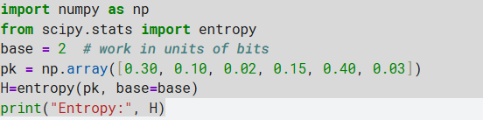

Or use the Entropy Calculator to check if your calculations are correct. https://planetcalc.com/2476/

Answer 5 / Discussion:

Part 2 – Coding and Compression Theory (20 Marks)

Question 6: Explain the difference between lossless and lossy compression?
(5 Marks)
Answer 6:

Question 7: Shannon formulated the theory of data compression and established that there is a fundamental limit to lossless data compression. What does this limit know as and what is it denoted as. (4 Marks)

Answer 7:

Question 8: Shannon-Fano and Huffman are types of lossless coding. Both coding methods are based on the same principles in the terms of character usage, frequency and code word length. Explain the overall principle behind them? (6 Marks)

Answer 8:

Question 9: Which of the coding methods, Shannon-Fano or Huffman typically offers the greatest efficiency? (5 Marks)

Answer 9:

Part 3 – Shannon Fano Coding (25 Marks)

Question 10: Explain the steps that must be taken to deduce a Shannon Fano code for a table of characters such as Table 1.
(5 Marks)

Answer 10:

Question 11: Deduce the Shannon Fano code for Table 1. Perform on paper and include image of your working out and obtained codewords.
(10 Marks)

Answer 11:

Place your image of your calculations and obtained codewords here

Question 12: Calculate the average number of bits (to 3 decimal places) produced by the coding method to represent the characters in Table 1.
(5 Marks)

Answer 12:

Place your image of your calculations here

Question 13: Calculate the efficiency of the coding obtained.
(5 Marks)

Place your image of your calculations here

Part 4 – Huffman Coding (30 Marks)

Question 14: Explain the steps that must be taken to deduce a Huffman code for a table of characters such as Table 1.
(5 Marks)
Answer 14:

Question 15: Deduce the Huffman code for Table 1. Perform on paper and include image of your working out and obtained codewords.
(15 Marks)

Place your image of your calculations and obtained codewords here

Question 16: Calculate the average number of bits (to 3 decimal places) produced by the coding method to represent the characters in Table 1.
(5 Marks)

Place your image of your calculations and obtained codewords here

Question 17: Calculate the efficiency of the coding obtained.
(5 Marks)

Place your image of your calculations here

Note: Submission
All questions to be answered and this document saved as a pdf and submitted on blackboard.

